WEEK 3: Spring-rest and JWT Exercises
Exercise 1:Create a Spring Web Project using Maven
SpringLearnApplication.java
package com.cognizant;
import org.springframework.boot.SpringApplication;
import org.springframework.boot.autoconfigure.SpringBootApplication;
import org.slf4j.Logger;
import org.slf4j.LoggerFactory;
@SpringBootApplication
public class SpringLearnApplication {
private static final Logger LOGGER = LoggerFactory.getLogger(SpringLearnApplication.class);
public static void main(String[] args) {
SpringApplication.run(SpringLearnApplication.class, args);
LOGGER.info("STARTED SpringLearnApplication");
}
}

Sample REST Controller HelloController.java
package com.cognizant.springlearn;
import org.springframework.web.bind.annotation.GetMapping;
import org.springframework.web.bind.annotation.RestController;
@RestController
public class HelloController {
@GetMapping("/hello")
public String sayHello() {
return "Hello from Spring Boot!";

Exercise 2: Spring Core – Load Country from Spring Configuration XML

SpringLearnApplication.java
package com.cognizant.springlearn;
import org.slf4j.Logger;
import org.slf4j.LoggerFactory;
import org.springframework.context.ApplicationContext;
import org.springframework.context.support.ClassPathXmlApplicationContext;
public class SpringLearnApplication {
private static final Logger LOGGER = LoggerFactory.getLogger(SpringLearnApplication.class);
public static void displayCountry() {
ApplicationContext context = new ClassPathXmlApplicationContext("country.xml");
Country country = context.getBean("country", Country.class);
// Debug Log
LOGGER.debug("Country : {}", country.toString());
// Console Output
System.out.println("Country Details:");
System.out.println("Code: " + country.getCode());
System.out.println("Name: " + country.getName());
}
public static void main(String[] args) {
displayCountry();
}
}

}
}
Output:
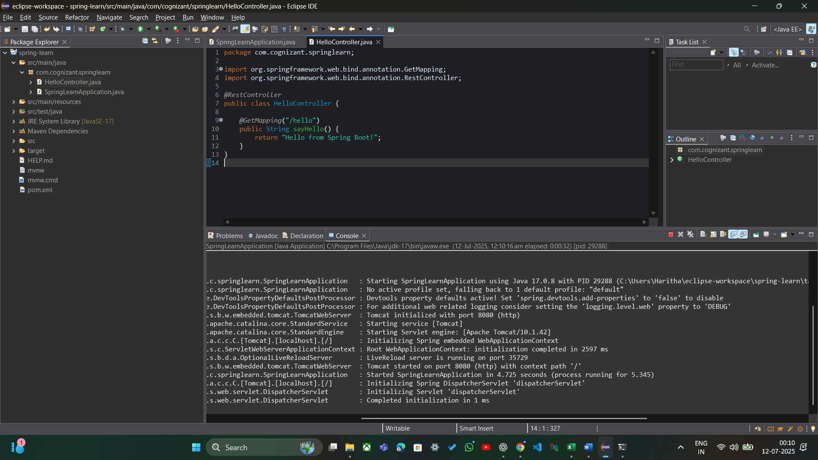

Country.java
package com.cognizant.springlearn;
import org.slf4j.Logger;
import org.slf4j.LoggerFactory;
public class Country {
private static final Logger LOGGER = LoggerFactory.getLogger(Country.class);
private String code;
private String name;
public Country() {
LOGGER.debug("Inside Country Constructor.");
}
public String getCode() {
LOGGER.debug("Inside getCode");
return code;
}
public void setCode(String code) {
LOGGER.debug("Inside setCode");
this.code = code;
}
public String getName() {
LOGGER.debug("Inside getName");
return name;
}
public void setName(String name) {
LOGGER.debug("Inside setName");
this.name = name;
}
@Override
public String toString() {
return "Country{" +
"code='" + code + '\'' +
", name='" + name + '\'' +
'}';
}
}

Output:

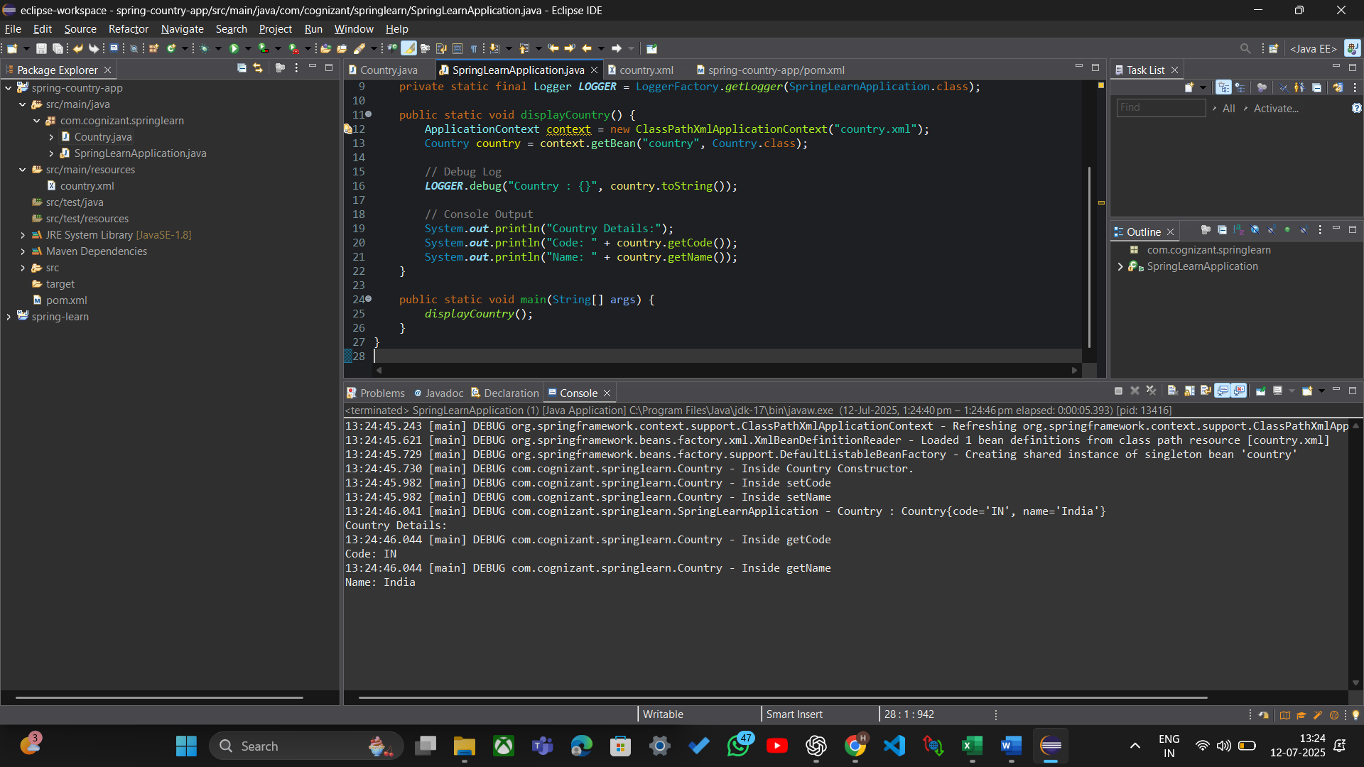

Exercise 3: Hello World RESTful Web Service

SpringLearnApplication.java

package com.cognizant.springlearn;
import org.springframework.boot.SpringApplication;
import org.springframework.boot.autoconfigure.SpringBootApplication;
@SpringBootApplication
public class SpringLearnApplication {
public static void main(String[] args) {
SpringApplication.run(SpringLearnApplication.class, args);
}
}

HelloController.java
package com.cognizant.springlearn.controller;
import org.slf4j.Logger;
import org.slf4j.LoggerFactory;
import org.springframework.web.bind.annotation.GetMapping;
import org.springframework.web.bind.annotation.RestController;
@RestController
public class HelloController {
private static final Logger LOGGER = LoggerFactory.getLogger(HelloController.class);
@GetMapping("/hello")
public String sayHello() {
LOGGER.info("START - sayHello()");
String message = "Hello World!!";
LOGGER.info("END - sayHello()");
return message;
}
}

Output:
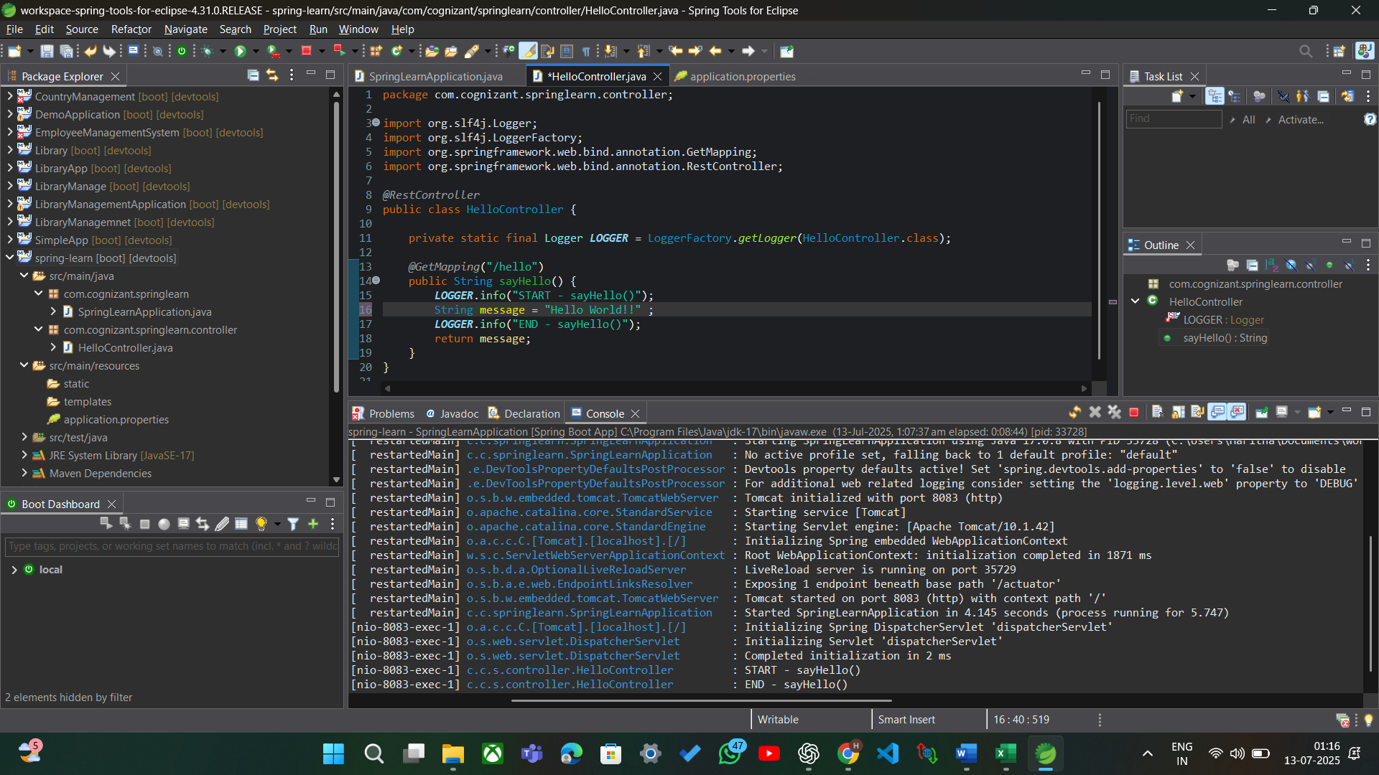

Exercise 4: REST - Country Web Service

SpringLearnApplication.java

package com.cognizant.springlearn;
import org.springframework.boot.SpringApplication;
import org.springframework.boot.autoconfigure.SpringBootApplication;
@SpringBootApplication
public class SpringLearnApplication {
public static void main(String[] args) {
SpringApplication.run(SpringLearnApplication.class, args);
}
}

Country.java
package com.cognizant.springlearn.model;
public class Country {
private String code;
private String name;
public Country() {}
public Country(String code, String name) {
this.code = code;
this.name = name;
}
public String getCode() {
return code;
}
public void setCode(String code) {
this.code = code;
}
public String getName() {
return name;
}
public void setName(String name) {
this.name = name;
}
}

CountryController.java
package com.cognizant.springlearn.controller;
import com.cognizant.springlearn.model.Country;
import org.slf4j.Logger;
import org.slf4j.LoggerFactory;
import org.springframework.context.ApplicationContext;
import org.springframework.context.support.ClassPathXmlApplicationContext;
import org.springframework.web.bind.annotation.RequestMapping;
import org.springframework.web.bind.annotation.RestController;
@RestController
public class CountryController {
private static final Logger LOGGER = LoggerFactory.getLogger(CountryController.class);
@RequestMapping("/country")
public Country getCountryIndia() {
LOGGER.info("START - getCountryIndia()");
ApplicationContext context = new ClassPathXmlApplicationContext("country.xml");
Country country = (Country) context.getBean("in");
LOGGER.info("END - getCountryIndia()");
return country;
}
}

Output:
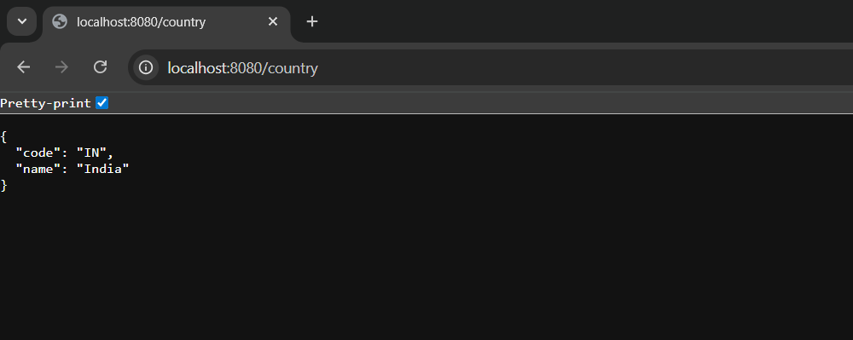
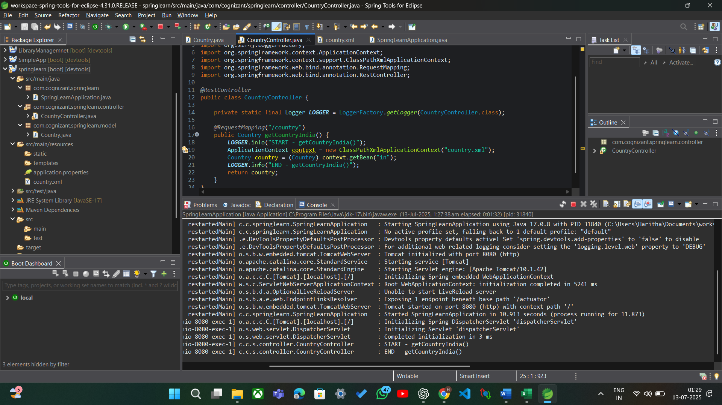

Exercise 5: REST - Get country based on country code

SpringLearnApplication.java

package com.cognizant.springlearn;
import org.springframework.boot.SpringApplication;
import org.springframework.boot.autoconfigure.SpringBootApplication;
@SpringBootApplication
public class SpringLearnApplication {
public static void main(String[] args) {
SpringApplication.run(SpringLearnApplication.class, args);
}
}

Country.java
package com.cognizant.springlearn.model;
public class Country {
private String code;
private String name;
public Country() {}
public Country(String code, String name) {
this.code = code;
this.name = name;
}
public String getCode() {
return code;
}
public void setCode(String code) {
this.code = code;
}
public String getName() {
return name;
}
public void setName(String name) {
this.name = name;
}
}

CountryController.java

package com.cognizant.springlearn.controller;
import com.cognizant.springlearn.model.Country;
import org.slf4j.Logger;
import org.slf4j.LoggerFactory;
import org.springframework.context.ApplicationContext;
import org.springframework.context.support.ClassPathXmlApplicationContext;
import org.springframework.web.bind.annotation.GetMapping;
import org.springframework.web.bind.annotation.RequestMapping;
import org.springframework.web.bind.annotation.RestController;
import java.util.List;
@RestController
public class CountryController {
private static final Logger LOGGER = LoggerFactory.getLogger(CountryController.class);

@RequestMapping("/country")
public Country getCountryIndia() {
LOGGER.info("START - getCountryIndia()");
ApplicationContext context = new ClassPathXmlApplicationContext("country.xml");
Country country = (Country) context.getBean("in");
LOGGER.info("END - getCountryIndia()");
return country;
}
@GetMapping("/countries")
public List<Country> getAllCountries() {
LOGGER.info("START - getAllCountries()");
ApplicationContext context = new ClassPathXmlApplicationContext("country.xml");
List<Country> countryList = (List<Country>) context.getBean("countryList");
LOGGER.info("END - getAllCountries()");
return countryList;
}
}
Output:
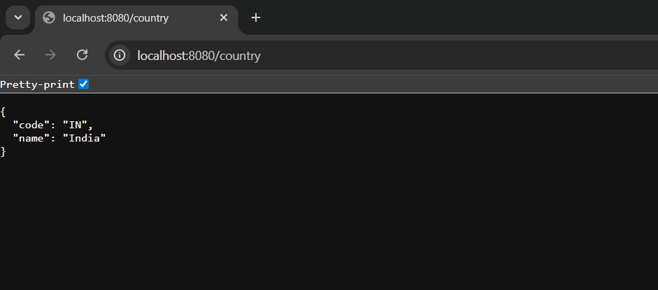

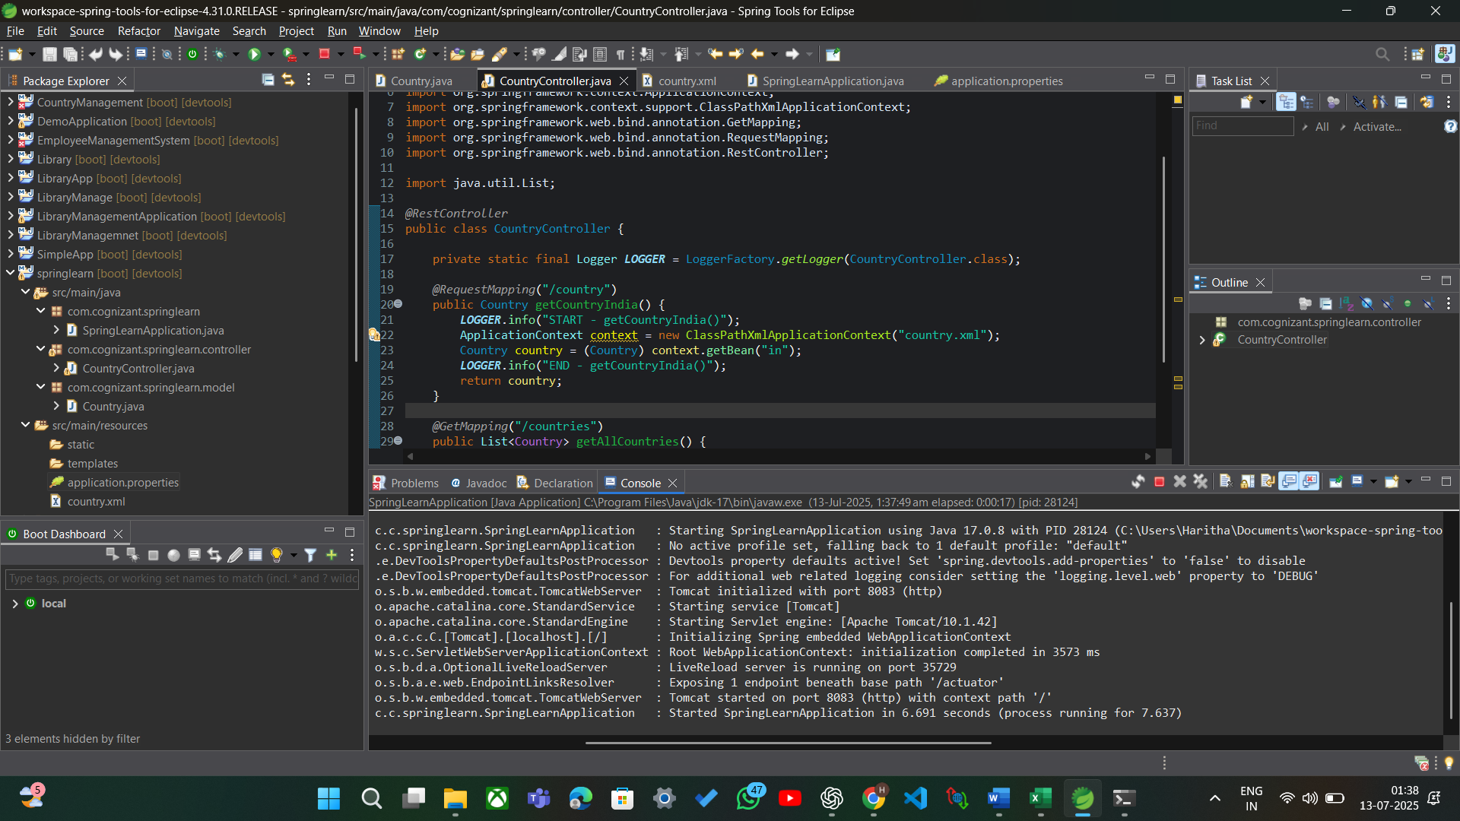

Exercise 1: Create authentication service that returns JWT

Pom.xml
<dependency>
<groupId>io.jsonwebtoken</groupId>
<artifactId>jjwt-api</artifactId>
<version>0.11.5</version>
</dependency>
<dependency>
<groupId>io.jsonwebtoken</groupId>
<artifactId>jjwt-impl</artifactId>
<version>0.11.5</version>
<scope>runtime</scope>
</dependency>
<dependency>
<groupId>io.jsonwebtoken</groupId>
<artifactId>jjwt-jackson</artifactId>
<version>0.11.5</version>
<scope>runtime</scope>
</dependency>

JwtUtil.java
package com.cognizant.util;
import io.jsonwebtoken.Jwts;
import io.jsonwebtoken.SignatureAlgorithm;
import io.jsonwebtoken.security.Keys;
import org.springframework.stereotype.Component;
import java.security.Key;
import java.util.Date;
@Component
public class JwtUtil {
private static final Key key = Keys.secretKeyFor(SignatureAlgorithm.HS256);
private static final long EXPIRATION_TIME = 10 * 60 * 1000; // 10 minutes
public String generateToken(String username) {
return Jwts.builder()
.setSubject(username)
.setIssuedAt(new Date())
.setExpiration(new Date(System.currentTimeMillis() + EXPIRATION_TIME))
.signWith(key)
.compact();
}
}

AuthenticationController.java
package com.cognizant.controller;
import com.cognizant.util.JwtUtil;
import org.springframework.http.ResponseEntity;
import org.springframework.web.bind.annotation.*;
import java.util.Base64;
import javax.servlet.http.HttpServletRequest;
@RestController
public class AuthenticationController {
private final JwtUtil jwtUtil;
public AuthenticationController(JwtUtil jwtUtil) {
this.jwtUtil = jwtUtil;
}
@GetMapping("/authenticate")
public ResponseEntity<?> authenticate(HttpServletRequest request) {
String authHeader = request.getHeader("Authorization");
if (authHeader == null || !authHeader.startsWith("Basic ")) {
return ResponseEntity.status(401).body("Missing or invalid Authorization header");
}

String base64Credentials = authHeader.substring("Basic ".length());
byte[] credDecoded = Base64.getDecoder().decode(base64Credentials);
String credentials = new String(credDecoded);
String[] values = credentials.split(":", 2);
String username = values[0];
String password = values[1];
if ("user".equals(username) && "pwd".equals(password)) {
String token = jwtUtil.generateToken(username);
return ResponseEntity.ok().body("{\"token\":\"" + token + "\"}");
} else {
return ResponseEntity.status(401).body("Invalid Credentials");
}
}
}

SecurityConfig.java
package com.cognizant.config;
import org.springframework.context.annotation.Configuration;
import org.springframework.security.config.annotation.web.builders.HttpSecurity;
import org.springframework.security.web.SecurityFilterChain;
import org.springframework.context.annotation.Bean;
@Configuration
public class SecurityConfig {
@Bean
public SecurityFilterChain filterChain(HttpSecurity http) throws Exception {
http
.csrf(csrf -> csrf.disable())
.authorizeHttpRequests(auth -> auth
.requestMatchers("/authenticate").permitAll()
.anyRequest().authenticated()
);
return http.build();
}
}

Output:
